**SQL Case Study: Texture Tales**

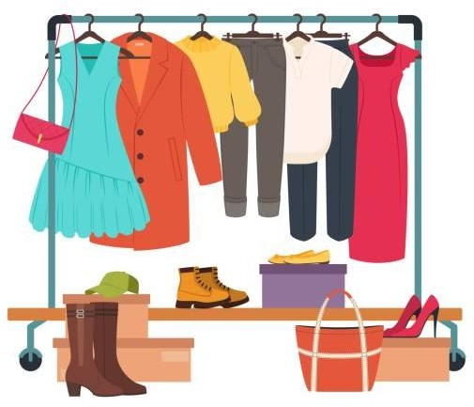

**INTRODUCTION:**

Texture Tales Clothing Company prides themselves on providing an optimized range of clothing and lifestyle wear for the modern adventurer!

I, the CEO of this trendy fashion company is asking you to assist the team’s merchandising teams analyze their sales performance and generate a basic financial report to share with the wider business

**SCHEMA USED**

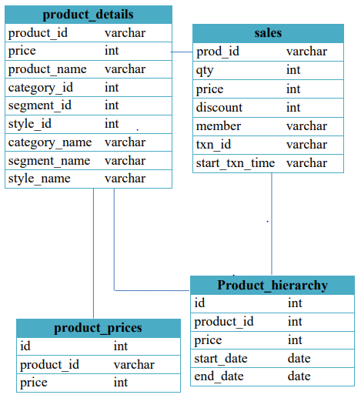

# CASE STUDY QUESTIONS

1. What was the total quantity sold for all products?
2. What is the total generated revenue for all products before discounts?
3. What was the total discount amount for all products?
4. How many unique transactions were there?
5. What are the average unique products purchased in each transaction?
6. What is the average discount value per transaction?
7. What is the average revenue for member transactions and non- member transactions?
8. What are the top 3 products by total revenue before discount?
9. What are the total quantity, revenue and discount for each segment?
10. What is the top selling product for each segment?
11. What are the total quantity, revenue and discount for each category?
12. What is the top selling product for each category?

First we have to create a Database :

Syntax: Create Database Database Name

Then we use this Databaes:

Syntax: Use Database Name

* create database Texture_Tales;
* use Texture_Tales;

------------------------------------------------------------------------------------------------

**1.What was the total quantity sold for all products?**

Solution:

SELECT b.product_name, SUM(a.qty) AS sale_counts

FROM sales AS a

INNER JOIN product_details AS b

ON a.prod_id = b.product_id

GROUP BY 1

ORDER BY 2 DESC;

Output:

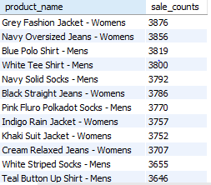

**2. What is the total generated revenue for all products before discounts?**

Solution:

Total Revenue = The amount of Product that are Sold and Price of Each Product

select sum(price * qty) as Revenue

from sales;

Output:



**3. What was the total discount amount for all products?**

Solution:

select sum(price * qty * discount)/100 as Total_Discount

from sales;

Output



**4. How many unique transactions were there?**

Solution:

select count(distinct txn_id) as Unique_Txn

from sales;

Output:

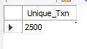

**5. What are the average unique products purchased in each transaction?**

Solution:

with cte_transaction_ptoduct as (

select txn_id,count(distinct prod_id) as Product_Cout

from sales

group by 1)

select avg(Product_Cout) as Avg_Uni_Pro

from cte_transaction_ptoduct;

(OR)

select avg(Product_Cout)

from

(select txn_id,count(distinct prod_id) as Product_Cout

from sales

group by 1) a

Output:

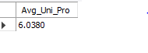

**6. What is the average discount value per transaction?**

Solution:

with cte_transaction_dicount as(

select txn_id, sum(price * qty * discount)/100 as Total_Discount

from sales

group by 1)

select avg(Total_Discount) as Avg_Discount

from cte_transaction_dicount;

-- ..................Same Code Without CTE...........

select avg(Total_Discount) as Avg_Disc

from

(select txn_id,sum(price * qty * discount) /100 as Total_Discount

from sales

group by 1) a

Output:



**7. What is the average revenue for member transactions and non - member transactions?**

with cte_member_revenue as(

select member,txn_id,sum(price * qty) as revenue

from sales

group by 1,2)

select member,avg(revenue) as avg_revenue

from cte_member_revenue

group by 1;

-- ..................Same Code Without CTE...........

select member,avg(revenue) avg_revenue

from

(select member,txn_id,sum(price * qty) as revenue

from sales

group by 1,2) a

group by 1

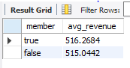

**8. What are the top 3 products by total revenue before discount ?**

Solution:

select b.product_name,sum(a.qty * a.price) as no_discount_revenue

from sales as a

inner join product_details as b

on a.prod_id = b.product_id

group by 1

order by 2 desc

limit 3;

Output:

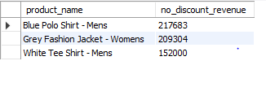

**9. What are the total quantity, revenue and discount for each segment?**

Solution:

select b.segment_id, b.segment_name, sum(a.qty) as Total_Quantity,

sum(a.qty * a.price) as Revenue,

sum(a.price * a.qty * a.discount)/100 as Total_Discount

from sales as a

inner join product_details b

on a.prod_id = b.product_id

group by b.segment_id,b.segment_name;

Output:

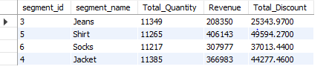

**10. What is the top selling product for each segment?**

Solution:

select b.segment_id,b.segment_name,b.product_id,b.product_name,sum(a.qty) as Product_Qty

from sales as a

inner join product_details as b

on a.prod_id = b.product_id

group by b.segment_id,b.segment_name,b.product_id,b.product_name

ORDER BY Product_Qty DESC

limit 5;

Output:

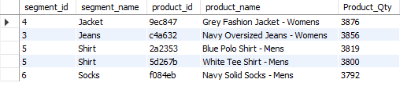

**11. What are the total quantity, revenue and discount for each category**

Solution:

select b.category_id,b.category_name, sum(a.qty) as Total_Quantity,

sum(a.qty * a.price) as Revenue,

sum(a.price * a.qty * a.discount)/100 as Total_Discount

from sales as a

inner join product_details as b

on a.prod_id = b.product_id

group by b.category_id,b.category_name

Output:

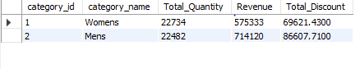

**12. What is the top selling product for each category?**

Solution:

select b.category_id,b.category_name,b.product_id,b.product_name,sum(a.qty) as Product_Qty

from sales as a

inner join product_details as b

on a.prod_id = b.product_id

group by b.category_id,b.category_name,b.product_id,b.product_name

ORDER BY Product_Qty DESC

limit 5;

Output:

